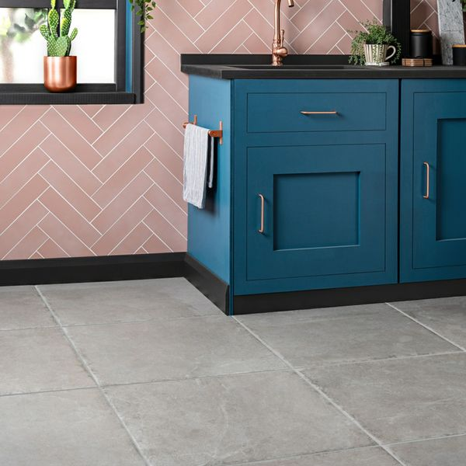**Witton Grey Stone:**

**Product Description**

Featuring all the character of natural stone in a durable porcelain body, Witton Grey Stone Effect Floor Tiles have a gorgeous, soft undulating surface and multiple unique variations which are a great choice for interior and exterior floor spaces. Their aged "tumbled" edge, in particular, exudes rustic charm. These tiles have a special "in/out" technology which means they have a smooth easy to clean surface but also remain anti-slip, making them suitable for any wet area and outdoors too.

**What's special about these tiles?**

> Neutral, grey tone

> Tumbled edge for aged charm

> On-trend stone effect design

> Textured, matt finish

> Strong R11 anti-slip surface

**Try before you buy**

If you'd like to take a closer look, why not order a sample tile? Samples are a great way to get a feel for a tile's true colour and texture, and you can see how it looks in your chosen room!

## **Product Info**

* Product ID: 44809
* Tiles Per SQM: 2.7777777777778
* Sale by: Per SQM
* Size: 600x600x9mm
* Weight: 7.29 KG
* Material Type: Porcelain
* Finish: Matt
* Colour: Grey
* Suitability: Floors, Walls
* Area Of Usage: Internal, External
* Grade: 4
* Rectified Edge: No
* Underfloor Heating: Yes
* Anti Slip Grade: R11 / 12 Degrees
* Thickness (mm): 9